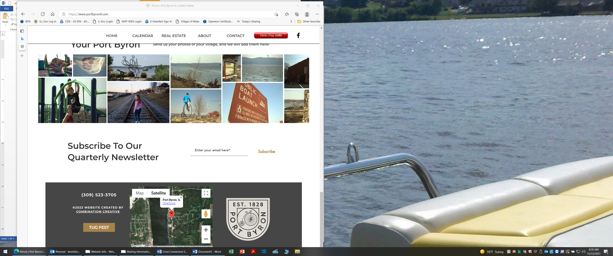
Port Byron Manganese Public Notice – Q3 2024
IMPORTANT INFORMATION ABOUT YOUR DRINKING WATER
Port Byron Has Levels of Manganese Above State Drinking Water Standards
Our water system recently violated a state drinking water standard. As our customers, you have a right to know what happened, what you should do, and what we are doing to correct this situation.
We routinely monitor for the presence of drinking water contaminants and are required to test quarterly for Manganese at our Well 4 location. Test results for this quarter, 7/1/24-9/30/24, show that our system exceeded the state maximum contaminant level (MCL), for manganese. The state MCL for manganese is 0.150 milligrams per liter (mg/L). The average level of manganese for a 4-sample set was 0.188 mg/L.
What should I do? What does this mean?
- DO NOT GIVE TAP WATER TO INFANTS. Formula and other food preparations for infants under 6 months old should not be prepared with tap water. Use bottled water or alternative sources of water for infants. Making formula or foods with water containing manganese levels above the health advisory can increase an infant’s risk of health problems.
- DO NOT BOIL THE WATER Boiling, freezing, or letting water stand does not reduce manganese. Boiling can increase levels of manganese because manganese remains behind when the water evaporates.
- Children and adults who drink water with high levels of manganese for a long time may have problems with memory, attention, and motor skills. Infants (babies under one year old) may develop learning and behavior problems if they drink water with too much manganese in it.
- Excessive manganese in the water may cause staining of plumbing fixtures and laundry. It may also produce an unpleasant taste in beverages, including coffee & tea.

What happened? What is being done?
The Village’s Well #4 Manganese test results in the past have been 0.16 – 0.20 mg/L which is slightly above the State MCL of 0.15 mg/L. The Village Board has approved construction of a Manganese & Iron Filtration Removal system for the Well 4 location. The Village and MSA are continuing work on design & funding of this project.

For more information, please contact Kevin Farrell, Water Operator at 309-523-3705 or
120 S Main St Port Byron, IL 61275.
Please share this information with all the other people who drink this water, especially those who may not have received this notice directly (for example, people in apartments, nursing homes, schools, and businesses). You can do this by posting this notice in a public place or distributing copies by hand or mail.
This notice is being sent to you by  Port Byron Water Department | Water System ID# | IL1610550 | Date distributed | 10/4/24p

